**Docker Compose:**

* It is a yaml file which includes the services,networks and volumes**.**
* It is used to create,run and maintain the multiple containers on single host.
* It is used to run the each service or option of application on individual containers in a single host.

**Steps to create the docker compose:**

* First create the ec2 instance and install docker on that server.
* Install the docker compose by using below command

**sudo curl -L https://github.com/docker/compose/releases/latest/download/docker-compose-$(uname -s)-$(uname -m) -o /usr/local/bin/docker-compose.**

* Give the execute permissions by using below command

**sudo chmod +x /usr/local/bin/docker-compose.**

* Check the version of docker compose by using **docker-compose --version** command**.**
* Create the docker compose file by using **vi docker-compose.yaml** command**.**

Docker compose file

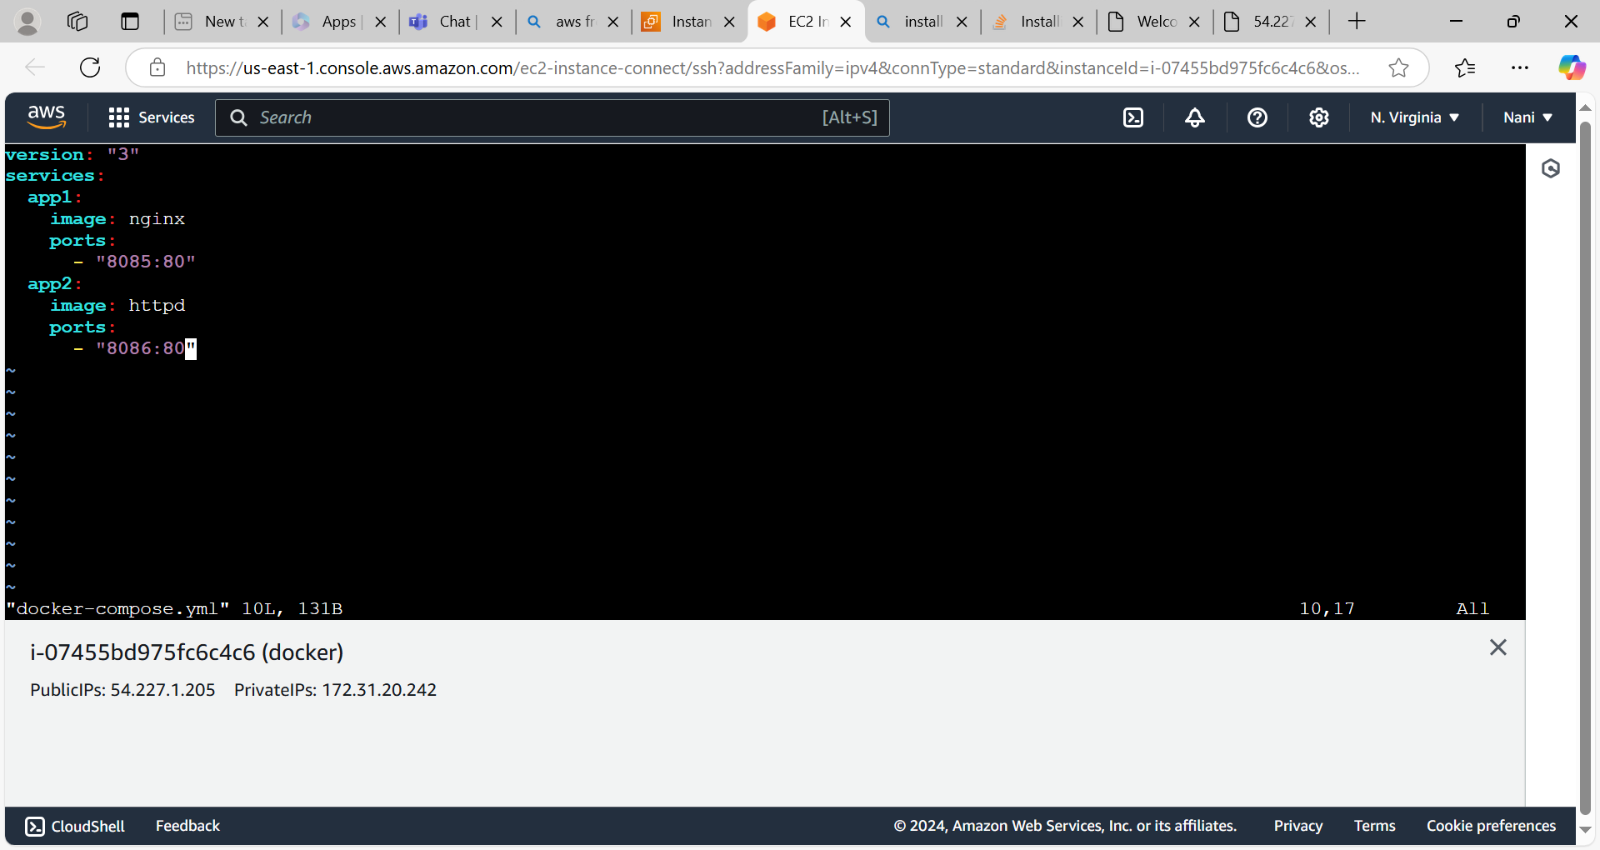

* Execute or start the docker compose file by using **docker-compose up or docker-compose up -d** command.
* Diff b/w compose up and compose up -d is when we use docker compose up command it will create ,start and stop or existed state the container immediately whereas docker-compose up -d command is create ,start and continuously running the container.

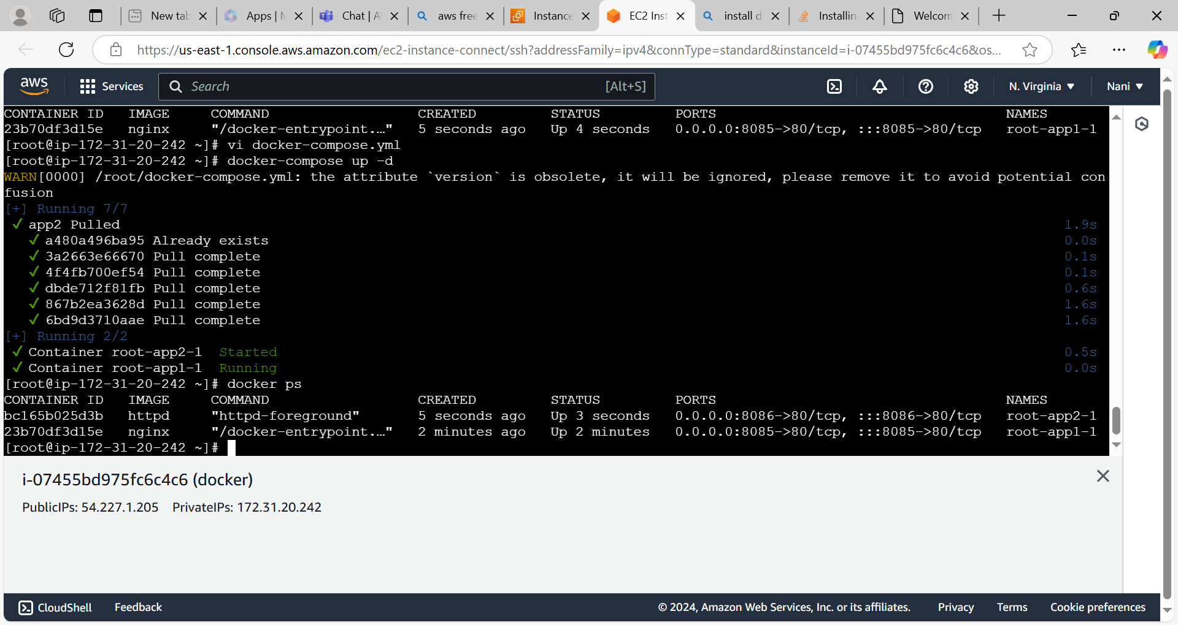

Access the nginx application

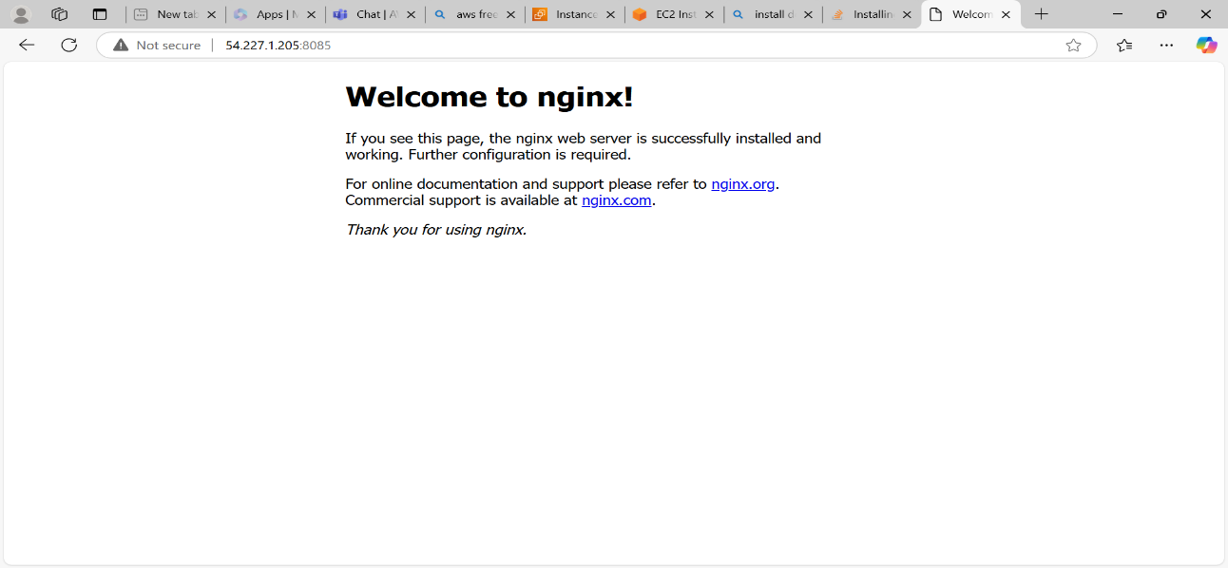

Access the httpd application

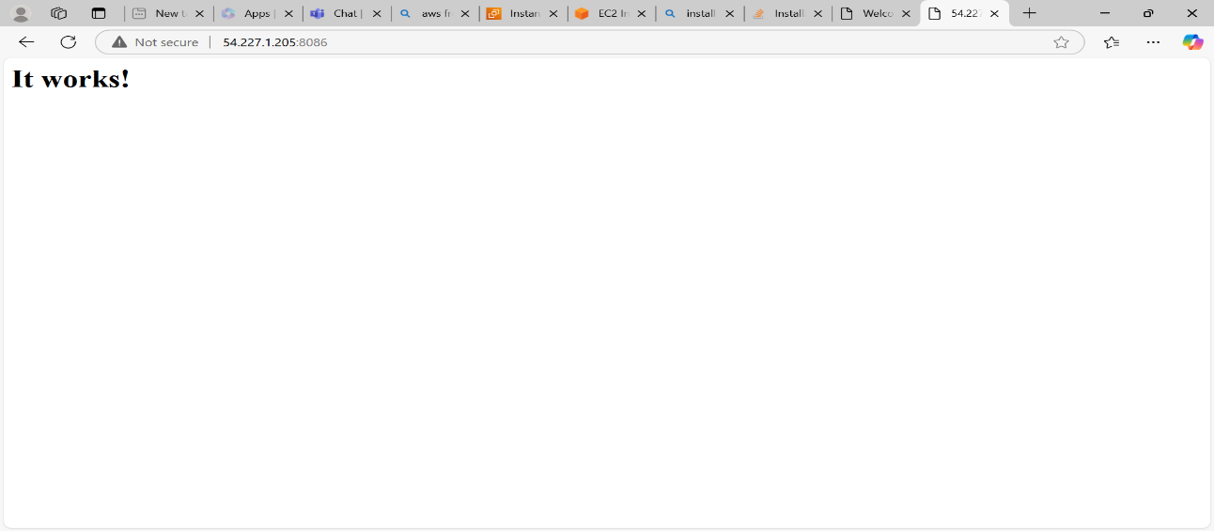

* By using the docker custom image from docker hub we can create and run the container.
* First log into our docker hub and we can configure the docker on the ec2 instance or server by using **docker login** command.
* Enter username and password.
* Open docker compose file which we have created earlier and add the service name like below image.

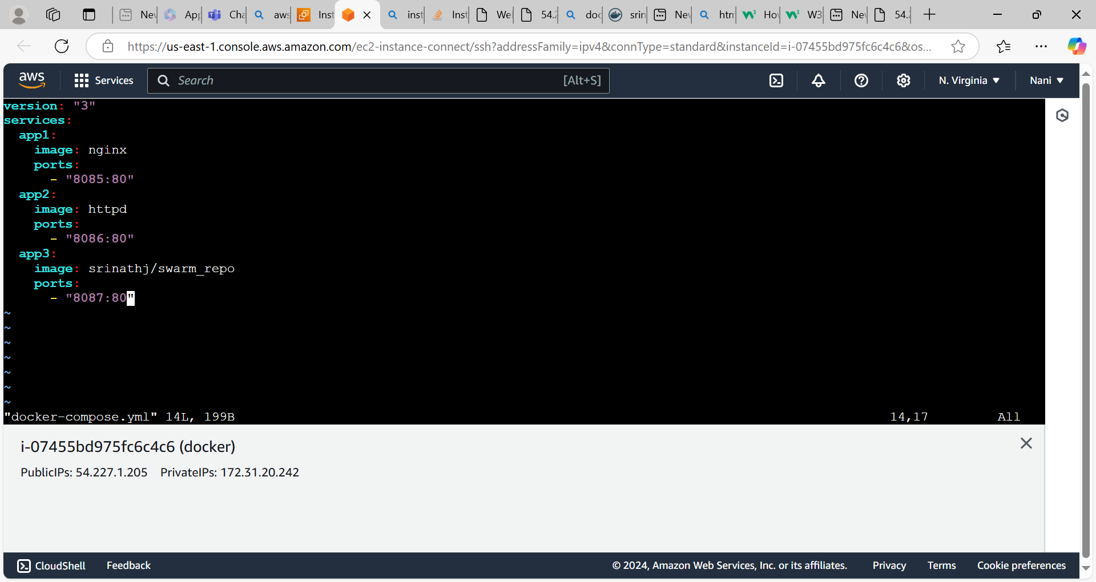

* Start the docker compose file by using **docker-compose up -d** command.

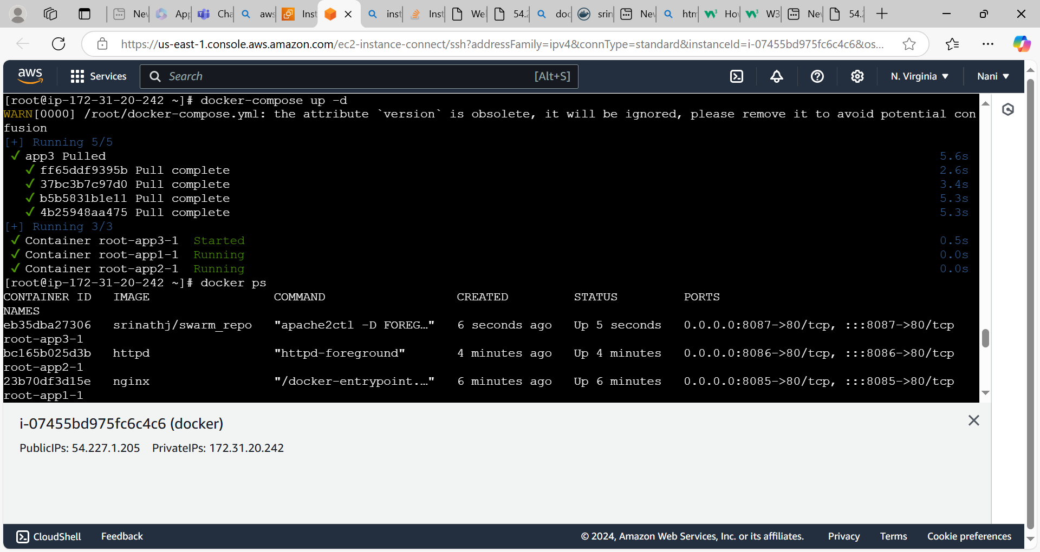

Access the application

